Northumberland LA - IAL User Guide
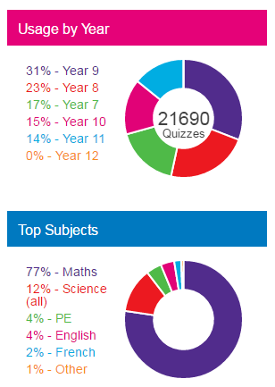
I am Learning is a games based revision and assessment system, its aim is to engage learners by allowing them to complete homework. It is popular with lower school students in particular as they can play games whilst answering questions. Upper school students can access past papers and choose KS4 revision topics.
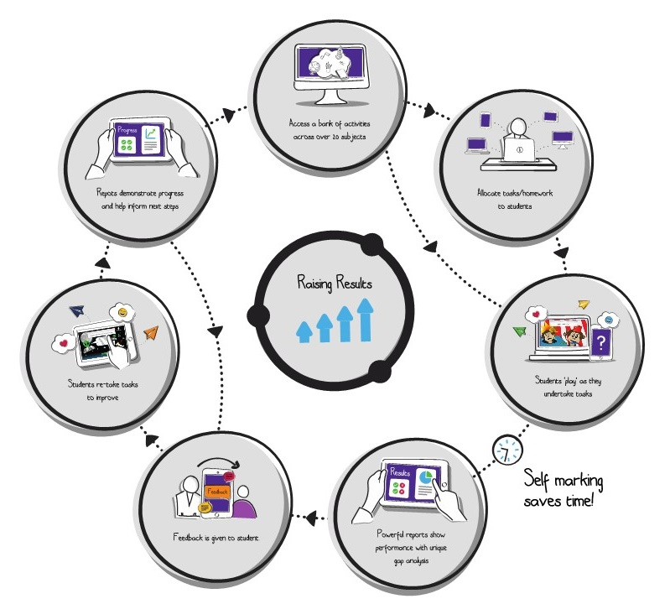
From a teaching perspective the main reason for using this tool is to raise results. It provides us with rich data about our students and classes; allowing us to look at reports on their performance and see where the gaps in understanding are. We are then able to focus attention on areas for development based on these gaps.

Accessing I am Learning
When you log on you’ll go to the home screen. Use the Quick Launch tool on the FrogBar to access the most common areas of I am Learning, i.e. Quizzes, Assignment Manager and Reports.
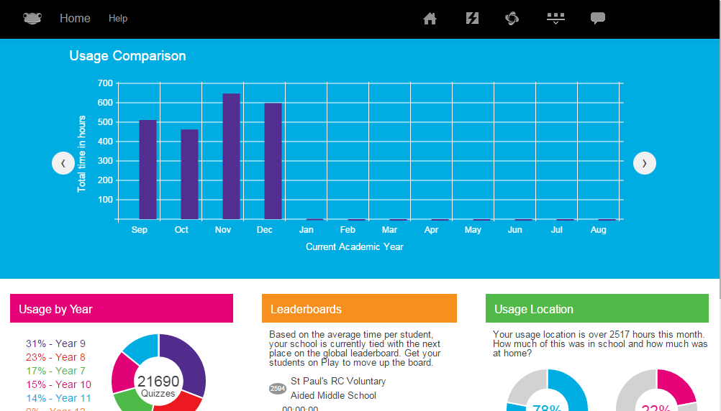
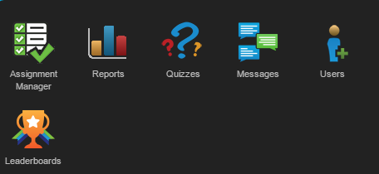

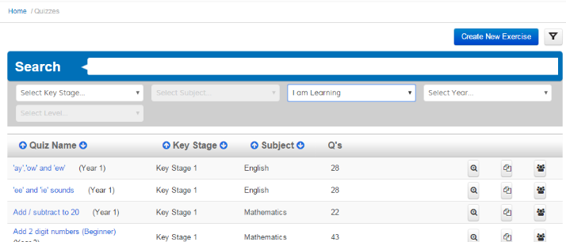
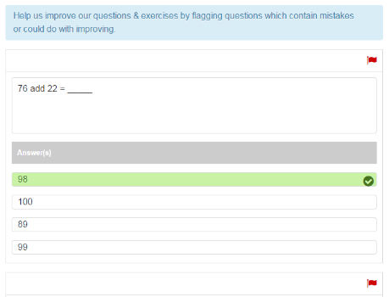
Quizzes
In this section you are able to search for existing quizzes using the filter tool.

There are already 170,000 questions ready to use in over 6,000 quizzes. These are just the questions and quizzes created by Frog Education; there is also access to questions and quizzes created by other schools in the Frog community.

It is also possible to copy existing quizzes and amend them before assigning them to your classes, as well as creating new quizzes from scratch. You can select an existing quiz and copy it so that you can change questions, create additional questions or delete questions before assigning the quiz. When you are happy with the quiz that you have created or amended you will need to publish it before assigning it to your students. This is the final step of creating a quiz. You can now publish to your school, publish to your school and community or save to edit later.
View
Allocate to Students
Copy

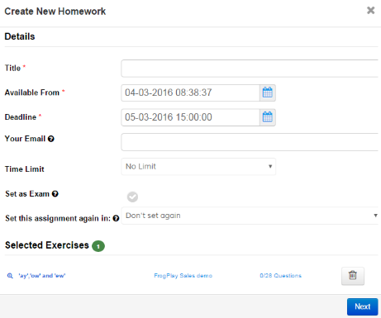
You are now ready to allocate a quiz straight to a cohort of students. Clicking on the ‘Allocate to Students’ icon will open up the Assignment tool which will walk you through the process of assigning to students.

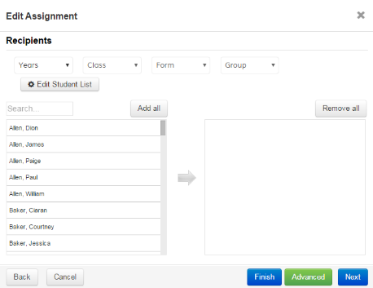
Give your assignment a title and then choose your start date and deadline and perhaps set a time limit on your assignment; or set it as an exam so that the games can’t be played; or even set the assignment to be repeated again. On the next screen you can use the filters and Edit Student List to find and add students, then hey presto!

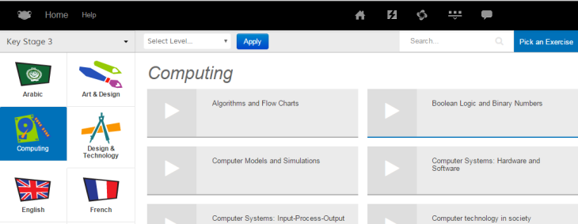
It’s also important to remember that the students can take any quiz independently themselves. In fact, they should be encouraged to do so as it will help them increase their knowledge and, of course, they play the games as they do this! For the students this is available to them from the ‘Revision’ area or ‘Quizzes’.

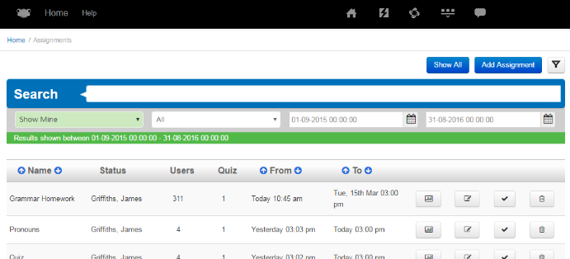
Assignment Manager
This allows you to see all the assignments you have set, including those which are overdue (highlighted in red). From here you are able to amend or delete an assignment, as well as assign out quizzes using Add Assignment.
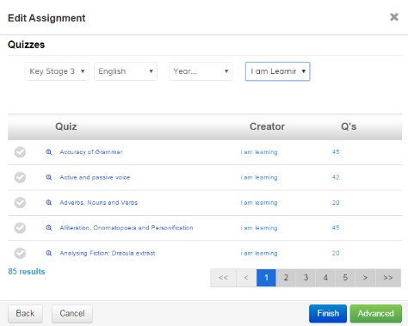
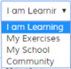
- Step 1: Provide details, such as homework name and deadlines.
- Step 2: Add your class, group or users.
- Step 3: Search for the exercise; you can search for exercises that have been created by I am Learning, you, your school or created by other schools. Tick the exercise you want to use.
- Step 4: Finish!

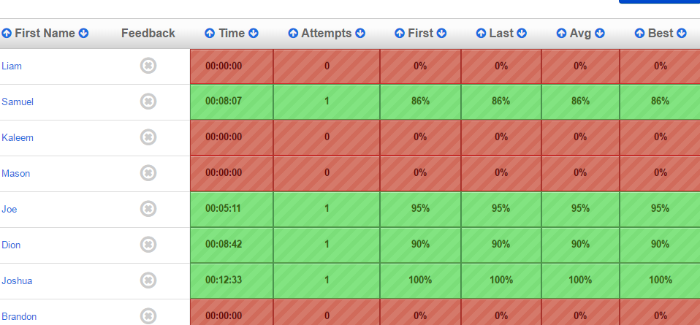
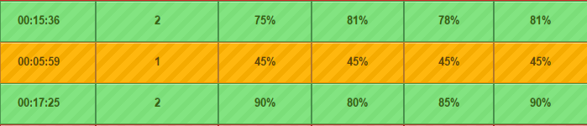
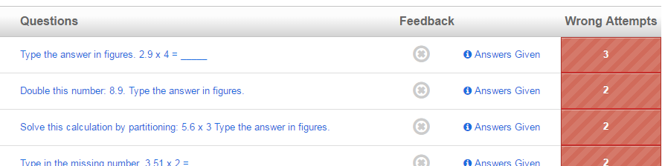
Once students have completed their homework and you are ready to review then you can access the homework reports from the Assignment Manager section. There is a report button available and this will provide you with a breakdown of how the students have performed.

The report will show % scores for each attempt as well as giving you detailed information on who answered questions incorrectly, how many students made the same mistake and even what answer they gave. Even better, all of this information is downloadable.

Reports
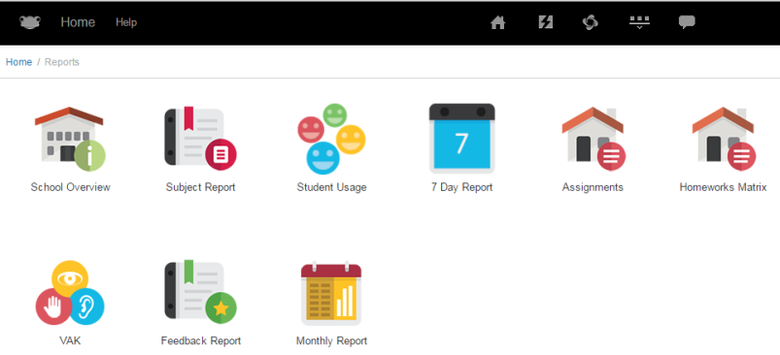
These enable you to analyse how students have performed across all exercises and will take into account any ‘revision’ the students have completed too. There are a variety of reports to access, however you are likely to find that you will use the ‘Homework Matrix’, ‘Subject Report’ and ‘Student Usage’ reports most. As mentioned earlier it is possible to download marks into a CSV file and then paste them into Excel.

