
Venues and Dates
Cramlington Hub
Eastlea Primary School
Monday 17th Nov. 4.00 – 5.00
Alnwick Hub
St. Michael’s First School
Tuesday 18th Nov. 4.00 – 5.00
Ponteland Hub
Ponteland First School
Wednesday 19th Nov. 4.00 – 5.00
Berwick Hub
Scremerston First School
Thursday 27th Nov. 4.00 – 5.00

This year we are continuing with our 4 hubs located around the county. The purpose of the hubs is to provide support locally for our schools in an informal way.
The hub leaders are fellow teachers who generously give their time to work with colleagues in their partnership and beyond. Their enthusiasm and involvement is infectious.
The meetings are for all teachers not just the ICT subject leader. Any school can attend even if you are not in any SLA’s!
If you haven’t been to a session before have a look inside to see what the meeting is about this term!

To help plan the sessions and make venue arrangements we would be grateful if you could make your booking via Julie Keenlyside.
julie.keenlyside@northumberland.gov.uk


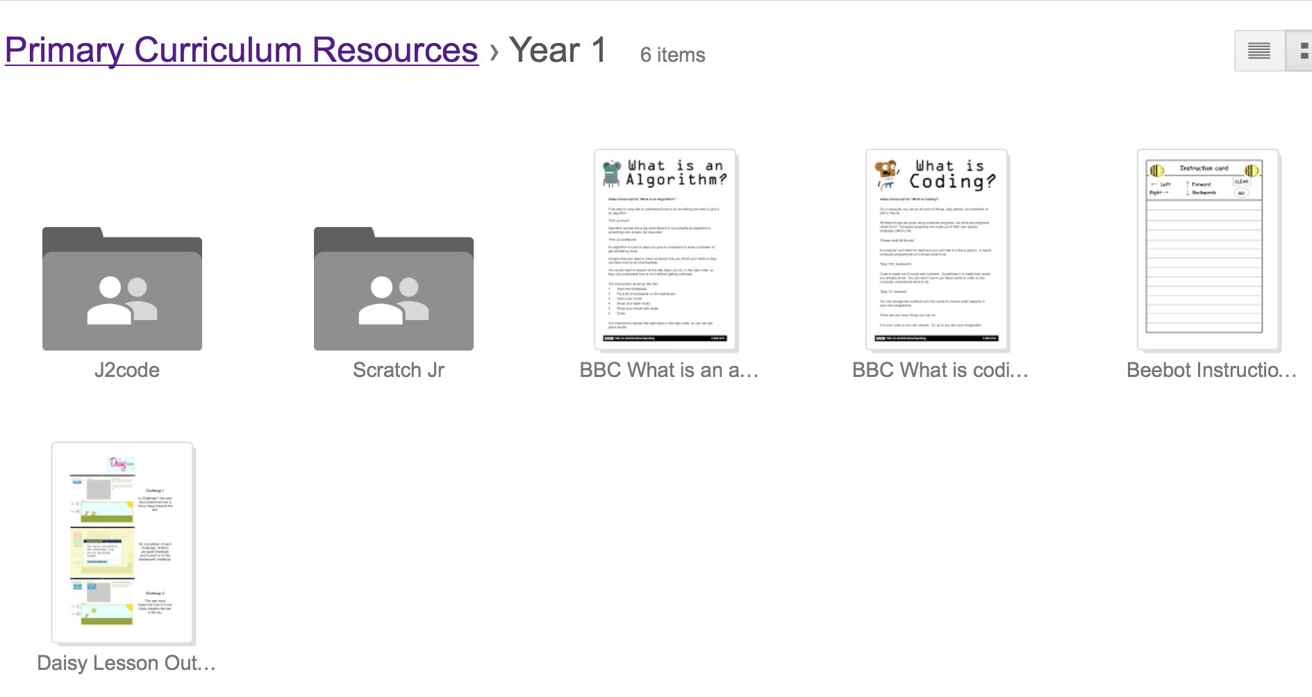
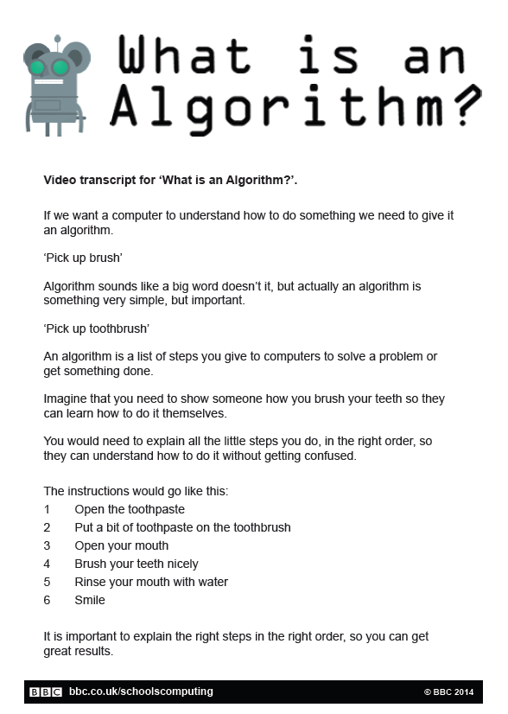
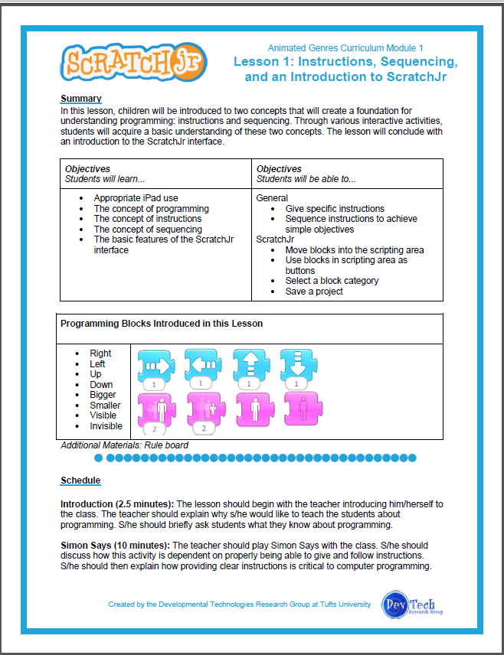
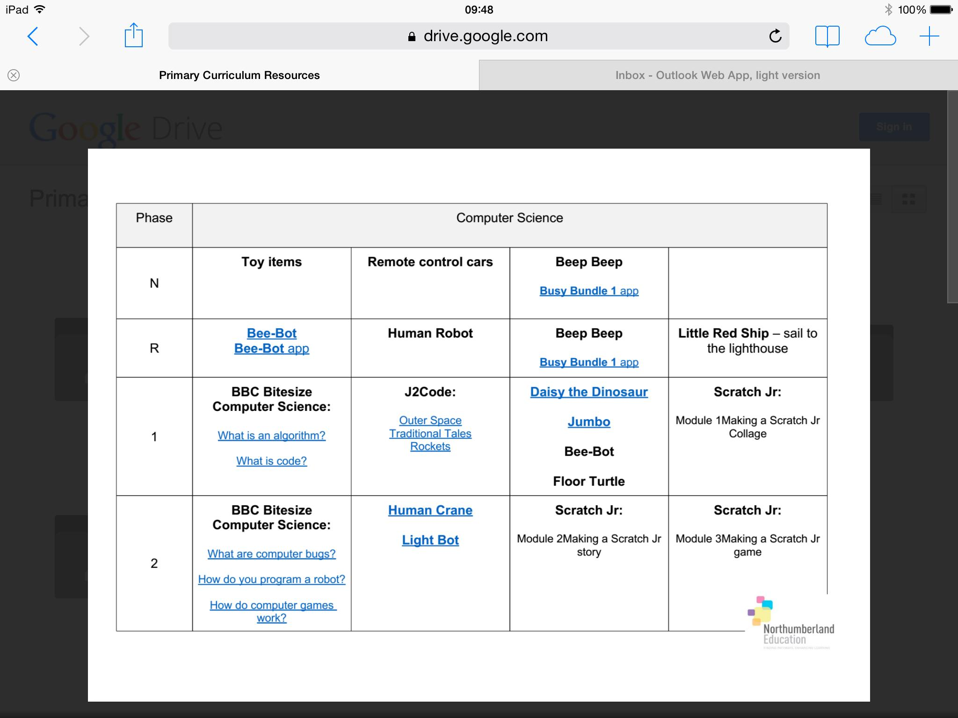
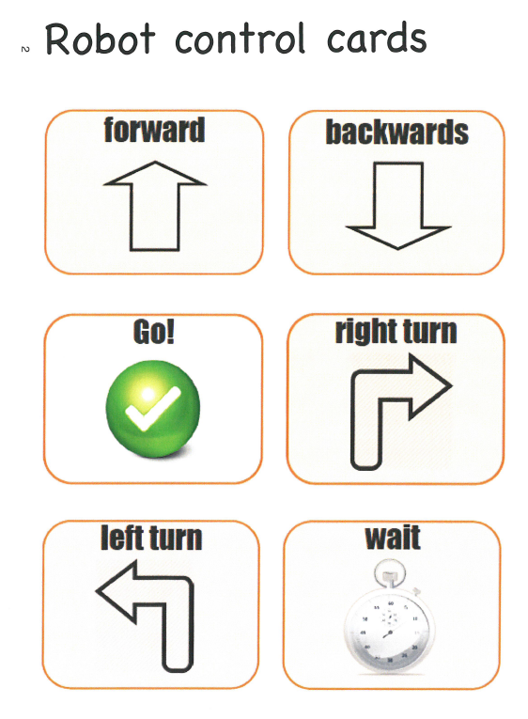
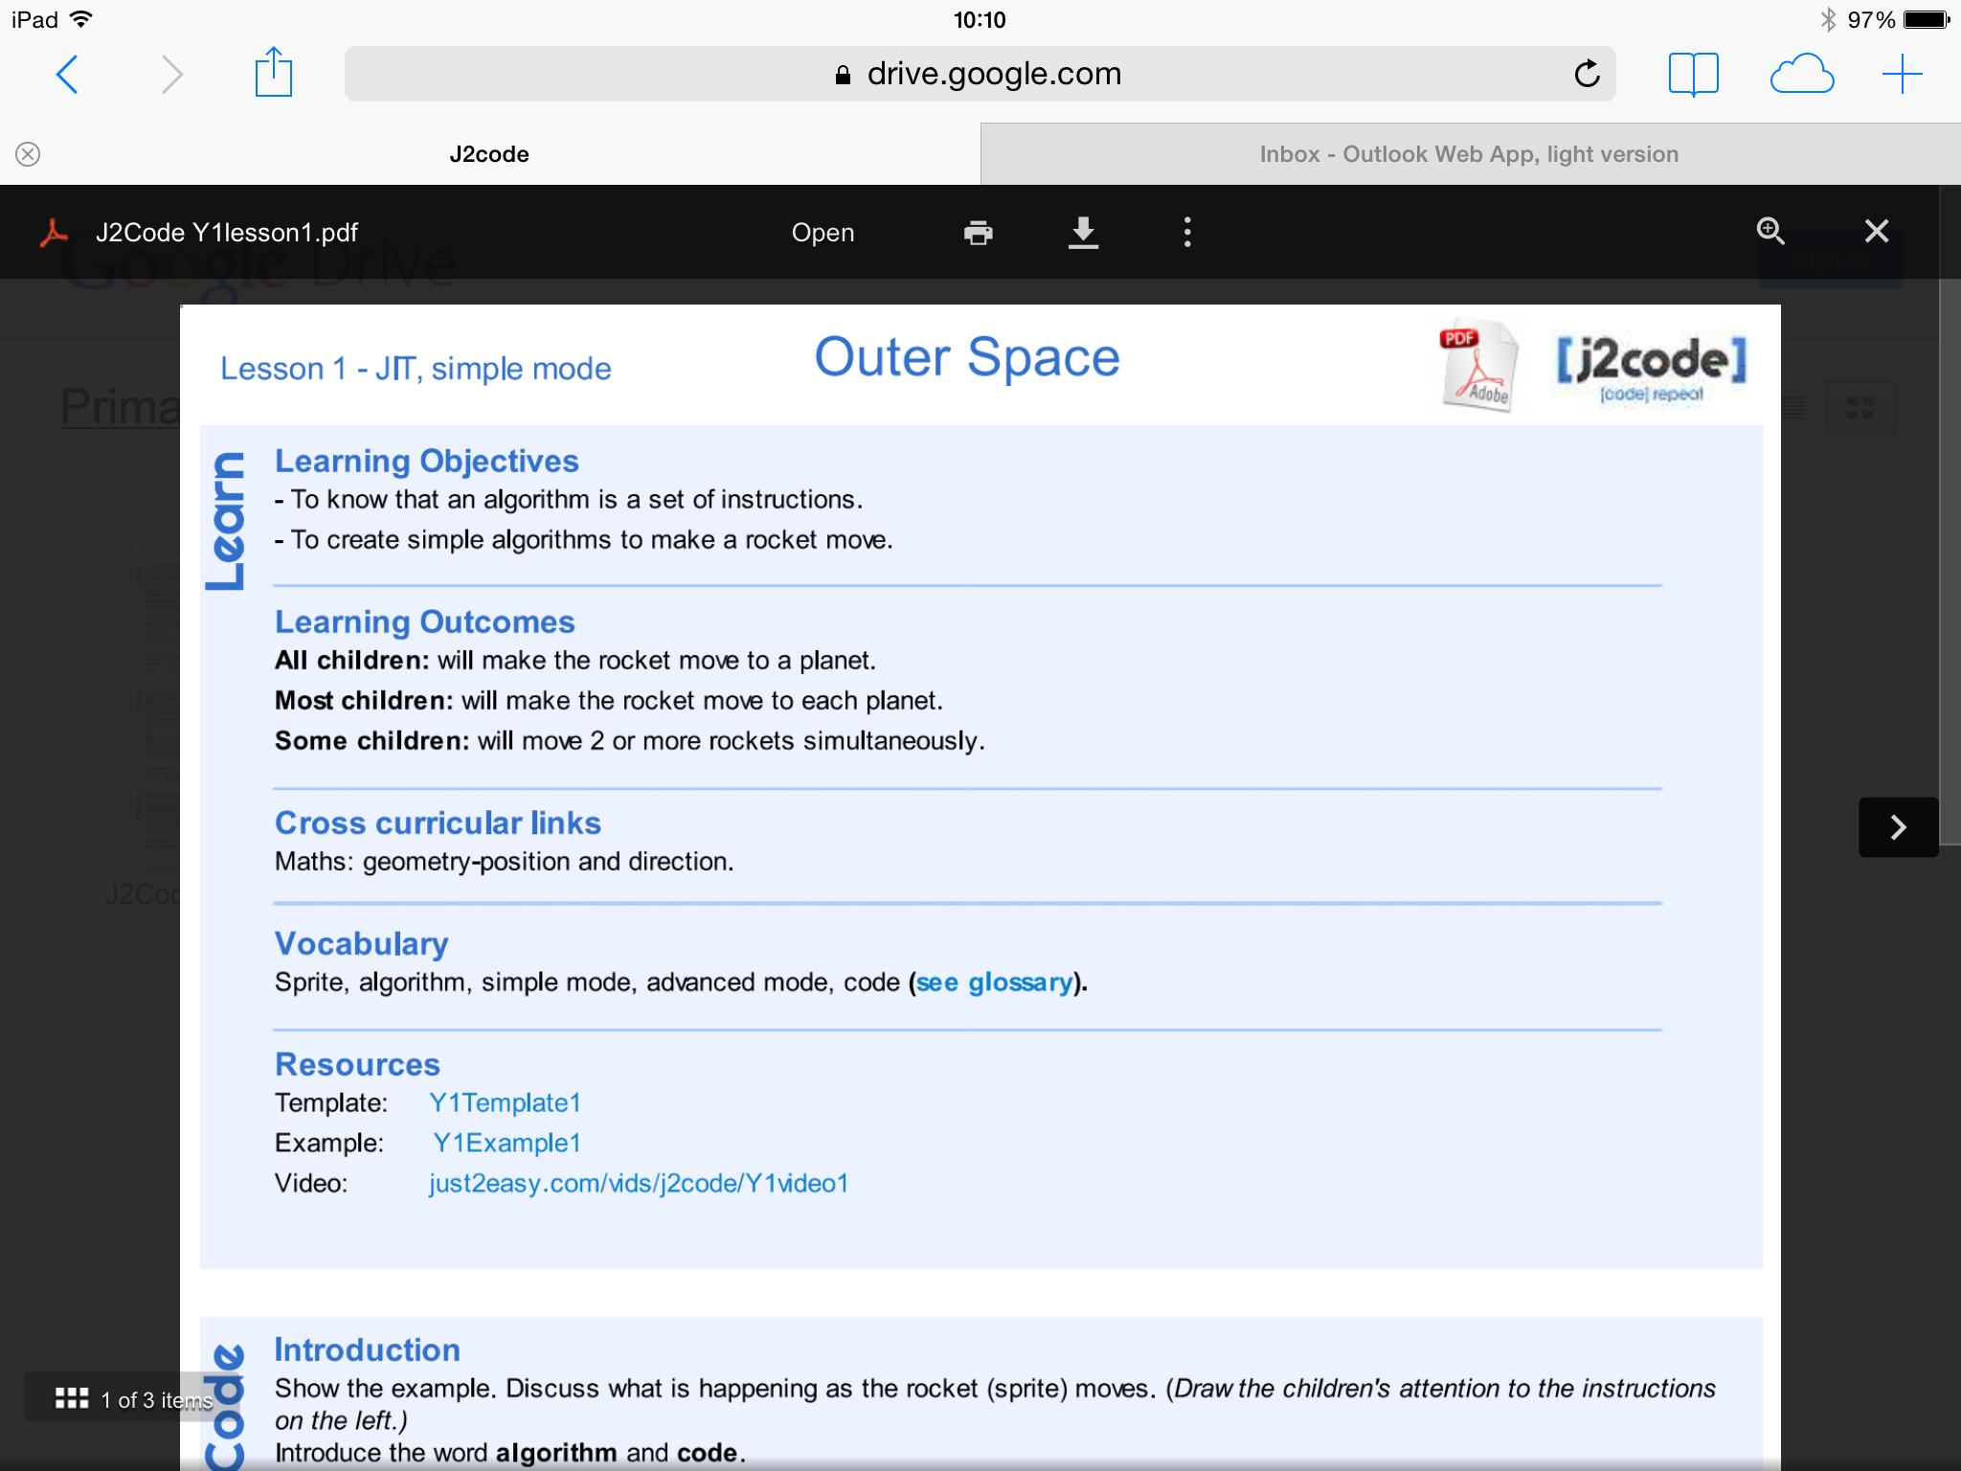
Session 1 - ‘How can you afford to miss this? Everything you need to know to teach computing to Early Years & Key Stage 1
Session 2 - Everything you need to know to teach computing to Key Stage 2
Spring 1 - Date to be arranged at session 1
Full Curriculum Map with linked Resources!!!

