Additional information

1. ICT Conference 31st March 2017 – The Village Hotel, North Tyneside
This year’s keynote speaker – Lee Parkinson will look at using technology to raise standards in the classroom. Lee will also be running a seminar session where he will outline his three step approach to improving writing through technology.
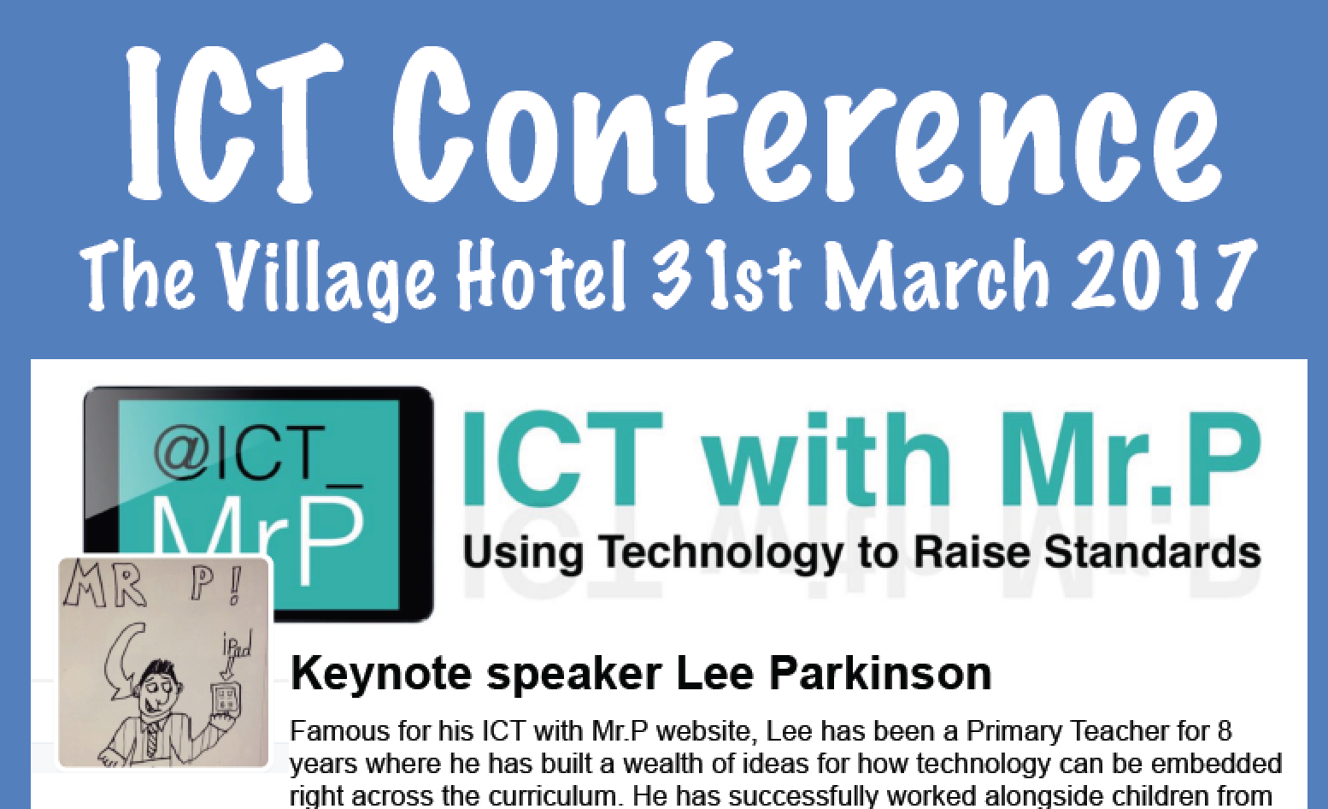
We also have sessions from Northumberland teachers on teaching computing from the Early Years to Key Stage 3, using Twitter, monitoring progress, Using Ozobots and Crumbles,
e-safety, Britannica online, J2blast new maths app and SAT preparation tool.
It looks like being a great conference and already half the available places are booked.
If you want to avoid disappointment and ensure your staff can get a place go to ngfl.northumberland.gov.uk and follow the conference link.

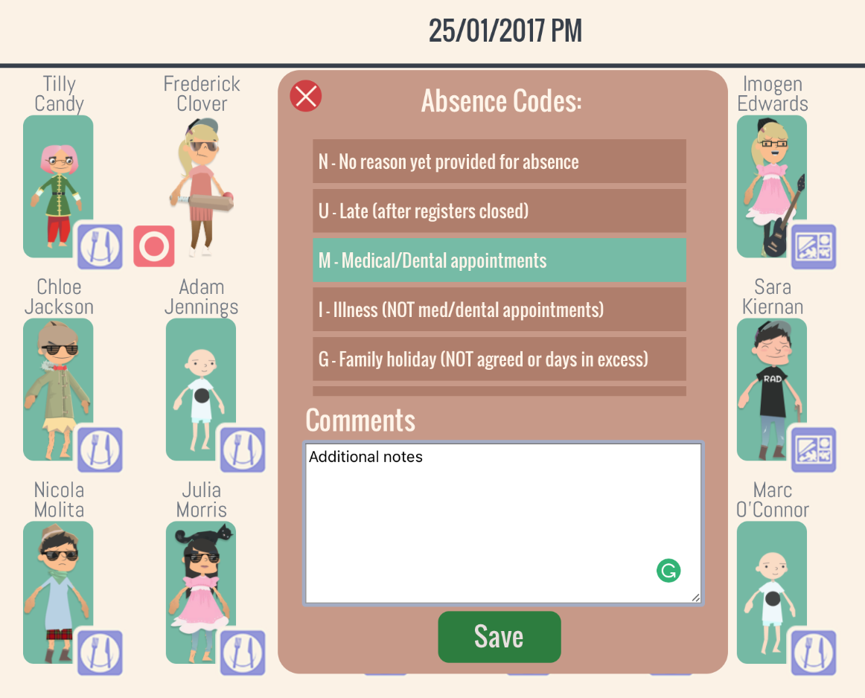
2. Register directly into SIMs – one year free trial open to all schools.
Last year we piloted using School360 to register directly into SIMs. The pilot was very successful and following feedback from schools we have added additional functionality such as a login for kitchen staff to see packed lunch and school dinner numbers.
We would now like to offer all schools a free trial of using School360 to register into SIMs. If you would like to sign up or would like a demonstration in school, please contact the ICT Curriculum Support Team.

3. Safe online searching with Britannica Online – this normally costs between £599 and £995 per school – you can access it for FREE through School360.
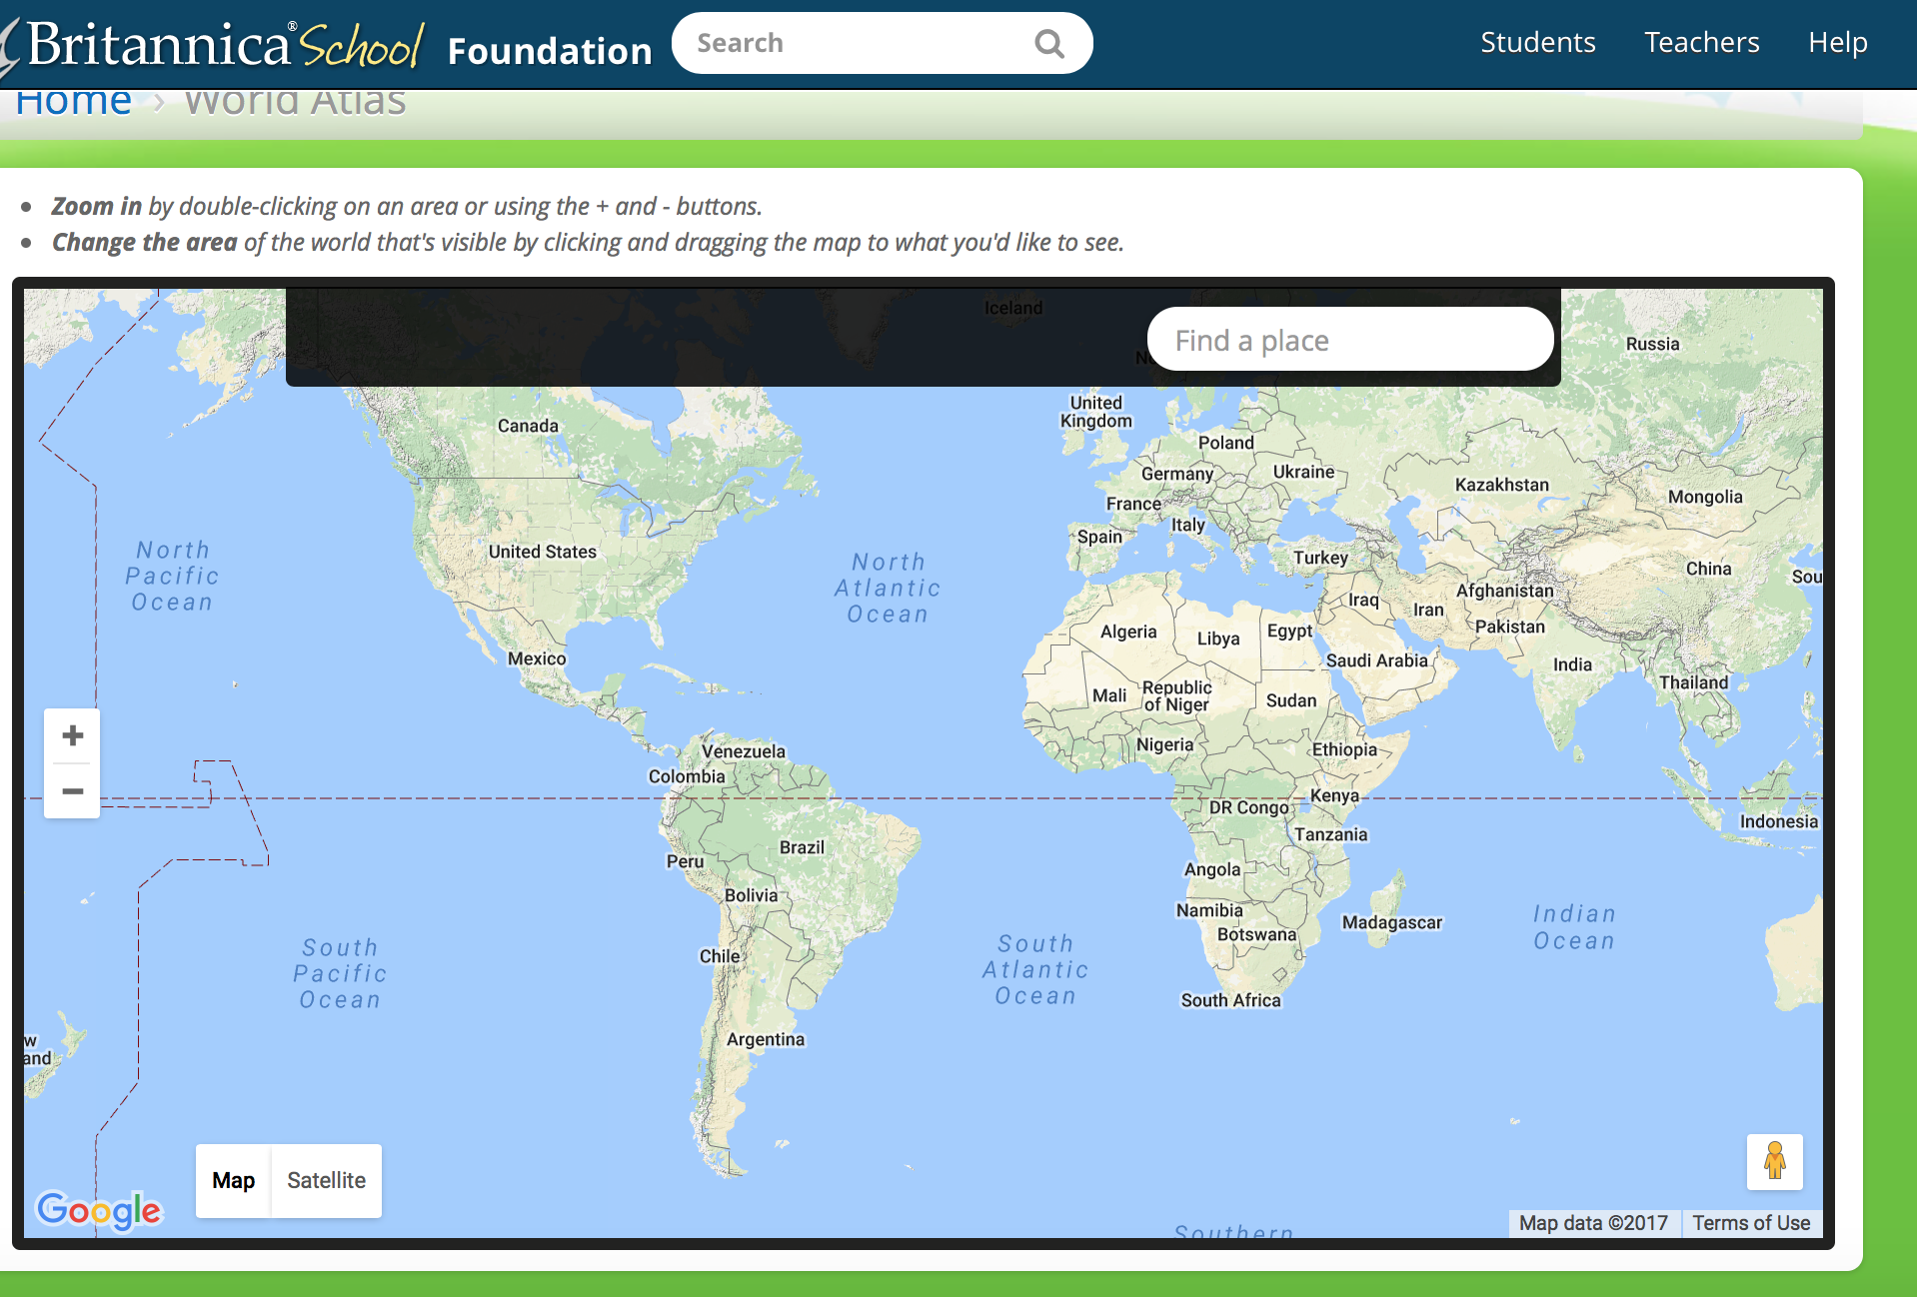
Britannica Online is a fantastic tool freely available within school360. It provides safe, secure searching with high quality and reliable content, as well as interactive maps, topic packs, content differentiated at three levels of ability and much more.
All accessible from home and school - is your school getting the most from this fantastic resource?
Contact the ICT Curriculum Support Team for a demonstration.

4. Parent App for iPhone and Android
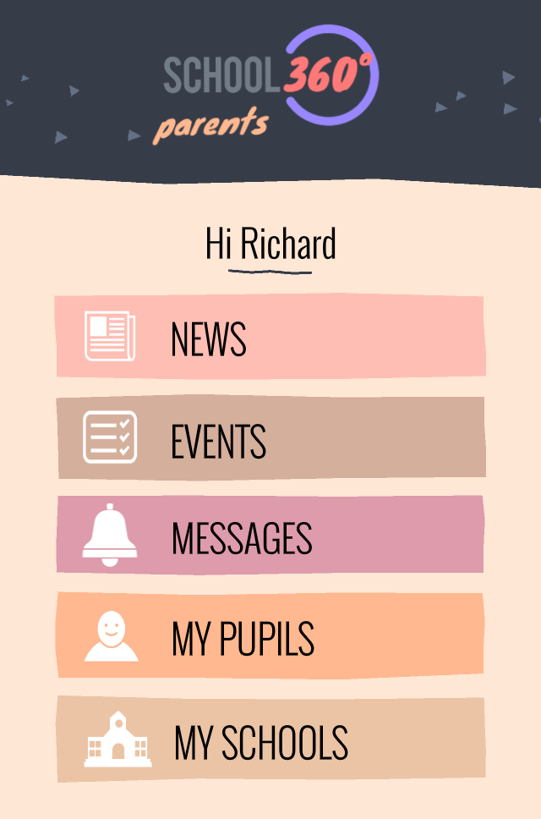
Having successfully trialed the App this year, we are now ready to roll it out to schools.
The app provides a number of tools including messaging to individual parents, groups, classes, behaviour/rewards reports to parents, calendar of events, as well as allowing parents to report absence.

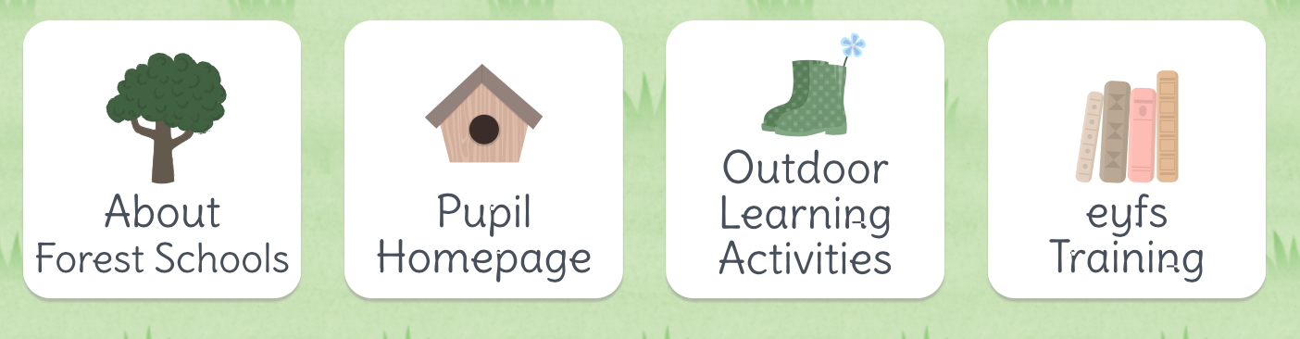
5. Simple login for Early Years
The new Early Years interface and login has been one of the most successful additions to School360 and is proving a real favourite with staff and pupils. It’s available FREE to all schools on School360 and provides some great additional tools including a forest school environment.
ShooFly are busy at the moment adding some additional tools for teachers to allow them to capture images, assess progress and monitor attainment.

6. Ozobots and Crumbles – great courses with FREE resources

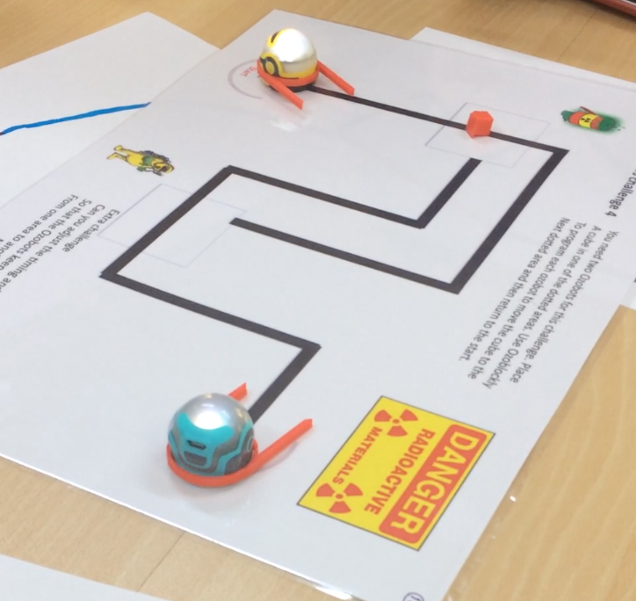
Ozobots are a fantastic, fun way to teach computing from
KS1- 3. They cost around £45 and course members get one FREE, along with lots of resources and activity ideas for the classroom. If a member of staff from your school has not yet attended an Ozobot course – look out for the next round – they are very popular!
Similarly Crumbles provide a great practical way to teach computing and control. At around £25 a kit they are reasonably priced and course members get two FREE.

Comments from recent courses include:
“I wanted to pass on a comment from a teacher at my school that attended the crumble training. She said it's the best training she's ever been on!” & “Yesterdays course was really awesome!”

Make sure your school doesn’t miss out on the training and resources!

- ICT and e-learning courses this term
We are busy planning courses for this year but intend to continue to have a strong focus on making the most of School360, teaching computing and e-safety.
One exciting development we are launching at the conference is our Treasure Island project. Developed by ShooFly publishing and utilizing the National Theatre video along with an e-book, and interactive resources such as Pirates Chest and other body parts!
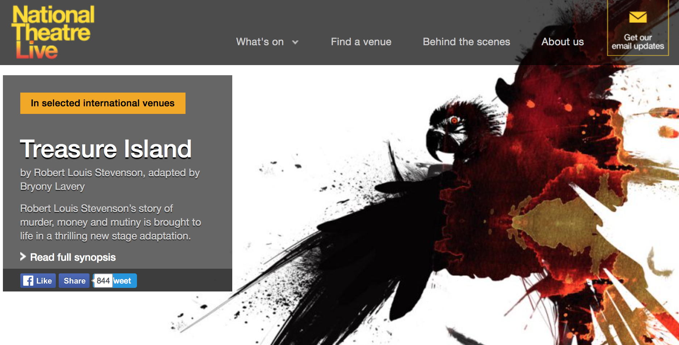
Courses up to Easter can be found on the ngfl.northumberland.gov.uk website and include sessions on Ozobots and Crumble. We are also happy to run sessions in your school or whole staff twilights. Get in touch with the ICT Curriculum Team to find out more or discuss your needs.

Kodu for Creative Writing 9th February 2017 Ashington Town Hall
1.00pm – 4.00pm

Kodu is a visual programming authoring tool, available on the PC and Xbox, which promotes game design, storytelling and problem solving.

Games Controllers 16th February 2017 Ashington Town Hall, 1.00pm – 4.00pm

This is a fun and practical way to get pupils engaged in computer programming with cross curricular links to design and technology. Course members will build a simple game controller to ‘plug’ into the computer and then create a simple program to control.

Mystery Lighthouse 14th March 2017 Ashington Town Hall, 1.00pm – 4.00pm

This is a fantastic and fun project aimed at pupils in KS 2 and 3, using iPads as both a stimulus for creative writing and also as a technology for recording notes and video animations. No prior knowledge of iPads is required and during the session colleagues will explore five different Apps:

Please email julie.keenlyside@northumberland.gov.uk to book a place on one of the above courses

