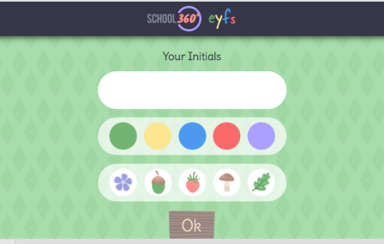
New EYFS interface on School360
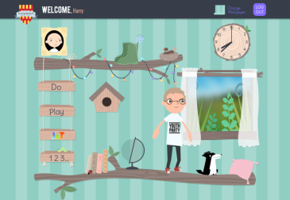
Come along to;
Find out how to make simple logins for the youngest pupils on School360.
Find out how to print the colourful logins for your class.
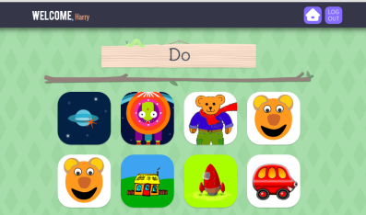
Be the first to see the EYFS interface.
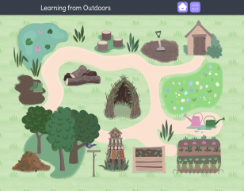
Learn how to select resources and share with your class
Have the opportunity to give your opinion and make suggestions
Dates and venues are:
Thursday 15th Sept, 4.00 pm - Tweedmouth West
Monday 19th Sept, 4.00 pm - Hexham East
Wednesday 21st Sept, 4.00pm - Ashington Town Hall
Thursday 22nd Sept, 4.00pm – St Michael’s, Alnwick
New EYFS interface on School360
Come along to;
Find out how to make simple logins for the youngest pupils on School360.
Find out how to print the colourful logins for your class.
Be the first to see the EYFS interface.
Learn how to select resources and share with your class
Have the opportunity to give your opinion and make suggestions
Dates and venues are:
Thursday 15th Sept, 4.00 pm - Tweedmouth West
Monday 19th Sept, 4.00 pm - Hexham East
Wednesday 21st Sept, 4.00pm - Ashington Town Hall
Thursday 22nd Sept, 4.00pm - St Michael’s, Alnwick

