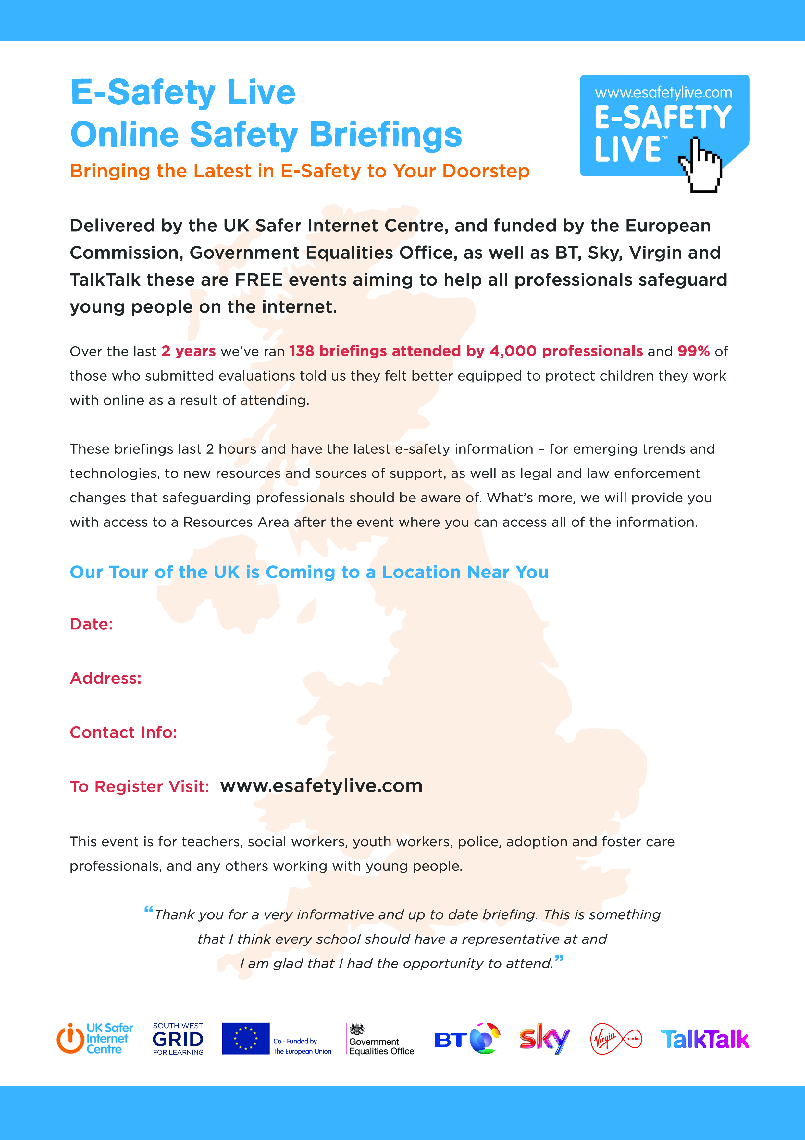

**Choppington Social Welfare Centre, Colliery Rd, Choppington , NE62 5SS**

**Friday 12th June 2015 2:30 – 4:30 pm**

**richard.taylor@northumberland.gov.uk**